AUTOMATIC ATTENENDANCE SYSTEM

**SEMINAR-1 REPORT**

***Submitted by***

# NANDHINI V (RA2111003020488)

# VASUPRATHA M(RA2111003020439)

# PRAMIKHA K (RA2111003020633)

### Under the guidance of

**Mr. N. Satish, M.E.,**

**Ms. K. Sivasankari, M.E.**

**(Assistant Professors, Department of Computer Science and Engineering)**

***In partial fulfillment for the award of the degree***

***of***

**BACHELOR OF TECHNOLOGY**

***in***

## COMPUTER SCIENCE AND ENGINEERING

***of***

## COLLEGE OF ENGINEERING AND TECHNOLOGY



**SRM INSTITUTE OF SCIENCE AND TECHNOLOGY RAMAPURAM, CHENNAI-600089.**

**NOVEMBER 2023**

**SRM INSTITUTE OF SCIENCE AND TECHNOLOGY**

(Deemed to be University Under Section 3 of UGC Act, 1956)

**BONAFIDE CERTIFICATE**

Certified that the Seminar-I report titled “**AUTOMATIC ATTENDANCE SYSTEM**” is the bonafide work of “**NANDHINI V [RA2111003020488], VASUPRATHA M [RA2111003020439], PRAMIKHA K [RA2111003020633]**” submitted for the course 18CSP103L Seminar – I. This report is a record of successful completion of the specified course evaluated based on literature reviews and the supervisor. No part of the Seminar Report has been submitted for any degree, diploma, title, or recognition before.

#### SIGNATURE SIGNATURE

Mr. N. Satish, M.E.,

Ms. K. Sivasankari, M.E., Dr. K. RAJA, M.E., Ph.D.,

Assistant Professor Professor and Head

Dept. of Computer Science & Engineering Dept. of Computer Science & Engineering

SRM Institute of Science and Technology SRM Institute of Science and Technology Ramapuram, Chennai. Ramapuram, Chennai.

Submitted for the Seminar-1 Viva Voce Examination held on at SRM Institute of

Science and Technology, Ramapuram, Chennai-600089.

**EXAMINER 1 EXAMINER 2**

**ABSTRACT**

The Automatic Attendance System (AAS) is a technological innovation aimed at revolutionizing traditional attendance management across various sectors, including education, corporate environments, and other organizational settings. This abstract provides an overview of the key features and benefits of our proposed AAS, emphasizing its potential to improve efficiency, accuracy, and overall accountability.

The Automatic Attendance System integrates cutting-edge technology, including biometric recognition, RFID (Radio-Frequency Identification), and mobile applications, to create a comprehensive and user-friendly attendance tracking solution. Users, such as students or employees, can conveniently record their attendance by employing biometric markers like fingerprint or facial recognition, or by tapping their RFID-enabled ID cards. Real-time attendance data is collected and securely stored in a centralized database accessible through a web-based or mobile application interface.

**TABLE OF CONTENTS**

|  |  |  |
| --- | --- | --- |
| **C. No.** | **Title** | **Page No** |
| **ABSTRACT** |  | **iii** |
| **LIST OF FIGURES** |  | **vi** |

**LIST OF ANCRONYMS AND ABBREVATIONS vii**

### INTRODUCTION 1

* 1. About the system
  2. Existing system
  3. Proposed System & advantages
  4. Objective

**1.5** Scope of the System

### SYSTEM ANALYSIS 7

**2.1** Feasibility of study

**2.1.1** Technical feasibility

**2.1.2** Economic Feasibility

**2.1.3** Operational feasibility

* 1. System Environment
     1. Software requirements
     2. Hardware requirements

### SYSTEM TOOLS 9

**3.1** JAVA

**3.2** JSP

* 1. Ms-Access
  2. SERVLET

### SYSTEM DESIGN 12

* 1. Module Description
     1. Administrator Module
     2. Staffs Module
  2. Use Case Diagram
  3. System Flow Diagram
  4. Dataflow diagram
  5. ER Diagram

### SNAPSHOTS 20

* 1. Front-End
     1. Login Screen
     2. Home Page
     3. Add Student
     4. Add Staff
     5. Students List
     6. Output View
     7. View for changing Staff's & Student's password
     8. MySQL Work Bench View

### TESTING 25

* 1. Introduction
  2. Testing Methodologies
     1. Unit Testing
     2. System Testing
     3. Performance Testing
  3. Test Cases
     1. Agent and Admin Login Form
     2. Master Form

1. CONCLUSION 30
   1. Conclusion
   2. Future Enhancements
2. REFERENCES 32

### LIST OF FIGURES

|  |  |  |
| --- | --- | --- |
| **S.NO** | **FIGURE NAME** | **PAGE.NO** |
| **4.2** | Use Case Diagram | 14 |
| **4.3** | System Flow Diagram | 15 |
| **4.4** | Dataflow diagram | 17 |
| **4.5** | ER Diagram | 18 |
| **5.1.1** | Login Screen | 20 |
| **5.1.2** | Home Page | 20 |
| **5.1.3** | Add Student | 21 |
| **5.1.4** | Add Staff | 21 |
| **5.1.5** | Students List | 22 |
| 5**.1.6** | Output View | 22 |
| **5.1.7** | View for changing Staff's & Student's password | 23 |
| **5.1.8** | MySQL Work Bench View | 23 |

**LIST OF ANCRONYMS AND ABBREVATIONS**

### OS - OPERATING SYSTEMS

**DBMS - DATABASE MANAGEMENT SYSTEM ML - MACHINE LEARNING**

### SQL - STRUCTURED QUERY LANGUAGE DDL - DATA DEFINITION LANGUAGE DML - DATA MANIPULATION LANGUAGE HTML - HYPER TEXT MARKUP LANGUA CSS - CASCADING STYLE SHEETS

**UI - USER INTERFACE UX - USER EXPERIENCE**

# CHAPTER 1

**INTRODUCTION**

### About the System:

Analysis can be defined as breaking up of any whole so as to find out their nature, function etc. It defines design as to make preliminary sketches of; to sketch a pattern or outline for plan. To plan and carry out especially by artistic arrangement or in skillful wall. System analysis and design can be characterized as a set of techniques and processes, a community of interests, a culture and an intellectual orientation.

The various tasks in the system analysis include the following.

* + - Understanding application.
    - Planning.
    - Scheduling.
    - Developing candidate solution.
    - Performing trade studies.
    - Performing cost benefit analysis.
    - Recommending alternative solutions.
    - Selling of the system.
    - Supervising, installing and maintaining the system.

This system manages to the analysis of the report creation and develops manual entry of the student attendance. First design the student’s entry form, staff allocation and time table allocation forms. This project will help the attendance system for the department calculate percentage and reports for eligibility criteria of examination. The application attendance entry system will provide flexible report for all students.

.

### Existing System:

The Existing system is a manual entry for the students. Here the attendance will be carried out in the hand written registers. It will be a tedious job to maintain the record for the user. The human effort is more here. The retrieval of the information is not as easy as the records are maintained in the hand written registers.

This application requires correct feed on input into the respective field. Suppose the wrong inputs are entered, the application resist to work. So the user find it difficult to use.

### Proposed System & Advantages:

To overcome the drawbacks of the existing system, the proposed system has been evolved. This project aims to reduce the paper work and saving time to generate accurate results from the student’s attendance . The system provides with the best user interface. The efficient reports can be generated by using this proposed system.

### Advantages of Proposed System

* + - It is trouble-free to use.
    - It is a relatively fast approach to enter attendance
    - Is highly reliable, approximate result from user
    - Best user Interface
    - Efficient reports

### Objective:

“Attendance Management System” is software developed for maintaining the attendance of the student on the daily basis in the collage. Here the staffs, who are handling the subjects, will be responsible to mark the attendance of the students. Each staff will be given with a separate username and password based on the subject they handle . An accurate report based on the student attendance is generated here. This system will also help in evaluating attendance eligibility criteria of a student. Report of the student’s attendance on weekly and monthly basis is generated.

### Scope of the System:

The project can be implemented on intranet. Project can be updated in near future as and when requirement for the same arises, as it is very flexible in terms of expansion. With the proposed software of database Space Manager ready and fully functional the client is now able to manage and hence run the entire work in a much better, accurate and error free manner. The following are the future scope for the project.

* Discontinue of particular student eliminate potential attendance.
* Barcode Reader based attendance system.
* Individual Attendance system with photo using Student login.

# CHAPTER 2

**SYSTEM ANALYSIS**

### Feasibility Study

Feasibility of a new system means ensuring that the new system, which we are going to implement, is efficient and affordable. There are various types of feasibility to be determined.

### Technical Feasibility

The technical requirement for the system is economic and it does not use any other additional Hardware and software. Technical evaluation must also assess whether the existing systems can be upgraded to use the new technology and whether the organization has the expertise to use it.

This application depends on Microsoft office and intranet service, database.

Enter their attendance and generate report to excel sheet.

### Economical Feasibility

Development of this application is highly economically feasible.

The only thing to be done is making an environment with an effective supervision. It is cost effective in the sense that has eliminated the paper work completely. The system is also time effective because the calculations are

automated which are made at the end of the month or as per the user requirement.

### Operational Feasibility:

The system working is quite easy to use and learn due to its simple but attractive interface. User requires no special training for operating the system. Technical performance includes issues such as determining whether the system can provide the right information for the Department personnel student details, and whether the system can be organized so that it always delivers this information at the right place and on time using intranet services. Acceptance revolves around the current system and its personnel.

### System Environment

#### Software Requirements

* + - * **Operating System-** Windows 7 is used as the operating system as it is stable and supports more features and is user friendly.
      * **Front-End: Java** is used to develop front end Graphical User Interface.
      * **Database – M s -Access** is used as database as it easy to maintain and retrieve records by simple queries.

#### Hardware Requirements

* + - * **Inter Core i3** is used as processor because it is relatively fast and provide reliable and stable environment.
      * **RAM 1 GB** is used as it will provide fast reading and writing capabilities and will in turn support in processing.
      * **40 GB Hard disk** is used to store database.

# CHAPTER 3

## SYSTEM TOOLS

### JAVA:

Java is a general-purpose Computer-Programming Language that is Concurrent, Class-Based, Object-oriented, and specifically designed to have as few implementation dependencies as possible. It is intended to let application developers “Write once, run anywhere” (WORA), that can run on any Java Virtual Machine (JVM) regardless of Computer Architecture. Java was originally developed by JAMES GOSLING at SUN MICROSYSTEM (which has since been acquired by oracle corporation) and released in 1995 as a core component of sun Micro systems Java platform. The language derives much of its original features from Small Talk, with a syntax similar to C and C++, but it has fewer low-level facilities than either of them.

### JSP:

JSP is known as JAVA SERVER PAGES, is a technology that helps software developer create dynamically generated web pages based on HTML, XML, or other document types. Released in 1999 by SUN MICROSYSTEMS, JSP is similar to PHP and ASP, but it uses the java programming language.

### Ms-Access:

Microsoft Access is a Database Management System (DBMS) from Microsoft that combines the relational Microsoft Jet Database Engine with a graphical user interface and software development tools. It is a member of the Microsoft Office suite of applications, included in the professional and higher editions.

* Microsoft Access is just one part of Microsoft’s overall data management product strategy.
* It stores data in its own format based on the Access Jet Database Engine.
* Like relational databases, Microsoft Access also allows you to link related information easily. For example, Student and Fee Receipt data.
* It can also import or link directly to data stored in other applications and databases.
* As its name implies, Access can work directly with data from other sources, including many popular PC database programs, with many SQL (Structured Query Language) databases on the desktop, on servers, on minicomputers, or on mainframes, and with data stored on Internet or intranet web servers
* Access can also understand and use a wide variety of other data formats, including many other database file structures.
* You can export data to and import data from word processing files, spreadsheets, or database files directly.
* Access can work with most popular databases that support the Open Database Connectivity (ODBC) standard, including SQL Server, Oracle, and DB2.
  1. **SERVLET:**

Servlets are the Java programs that run on the Java-enabled web server or application server. They are used to handle the request obtained from the web server, process the request, produce the response, then send the response back to the web server.

* **MySQL Workbench** is a unified visual tool for database architects, developers, and DBAs. MySQL Workbench provides data modeling, SQL development, and comprehensive administration tools for server configuration, user administration, backup, and much more. MySQL Workbench is available on Windows, Linux and Mac OS X.
* **Apache Tomcat**, often referred to as Tomcat Server, is an open-source Java Servlet Container developed by the Apache Software Foundation (ASF). Tomcat implements several Java EE specifications including Java Servlet, JavaServer Pages (JSP), Java EL, and WebSocket, and provides a "pure Java" HTTP web server environment in which Java code can run.
* **Google Chrome Browser** is a cross-platform web browser developed by Google. It was first released in 2008 for Microsoft Windows, and was later ported to Linux, macOS, iOS, and Android. The browser is also the main component of Chrome OS, where it serves as the platform for web apps.

# CHAPTER 4

## SYSTEM DESIGN

### MODULE DESCRIPTION:

The system should be designed in such a way that only authorized people should be allowed to access some particular modules. The records should be modified by only administrators and no one else. The user should always be in control of the application and not the vice versa. The user interface should be consistent so that the user can handle the application with ease and speed. The application should be visually, conceptually clear.

### ADMINISTRATOR MODULE:

#### Student Details:

In this module deals with the allocation of roll no and personal details for new batch. It will generate of personal details of student and academic details of the students with the photos.

#### Staff Details:

* + - * + It helps to allot the subject and the subject code to the particular staffs.
        + It provides the facility to have a user name and password to the staffs.

#### Time table details:

* + - * + It will retrieve the subject information from the subject database and assign time table to the staffs.
        + It will help the admin, staff to make the entry of attendance based of the

subject and period allotted to the respective staff

#### Attendance details:

* + - * + It will be makes to the attendance database all students. Entered

attendance to stored in the database subject ,period wise into the particular date.

* + - * + It will help to the get report of weekly and consolidate of the attendance.

#### Report details:

* + - * + weekly report get all hour details of attendance starting date to ending date and display the status
        + Consolidate report get all student attendance details starting date to ending date status help for the eligibility criteria of the student to attend the examination.

### STAFFS MODULE:

#### Attendance details:

* + - * + It assists the staff to mark attendance to the students for their subject. This will authenticate the staff before making the entry.

#### Report details:

1. weekly report get particular hour details of attendance from starting date to ending date and display the status .

consolidate report get all student attendance details from starting date to ending date status help for the eligibility criteria of the student to attend the examination

### Use case Diagram:

A use case diagram in the Unified Modelling Language (UML) is a type of beh avioural diagram defined by and created from a Use-case analysis. Its purpose is to present a graphical overview of the functionality provided by a system in terms of actors, their goals (represented as use cases), and any dependencies between those use cases. The main purpose of a use case diagram is to show what system functions are performed for which actor. Roles of the actors in the system can be depicted

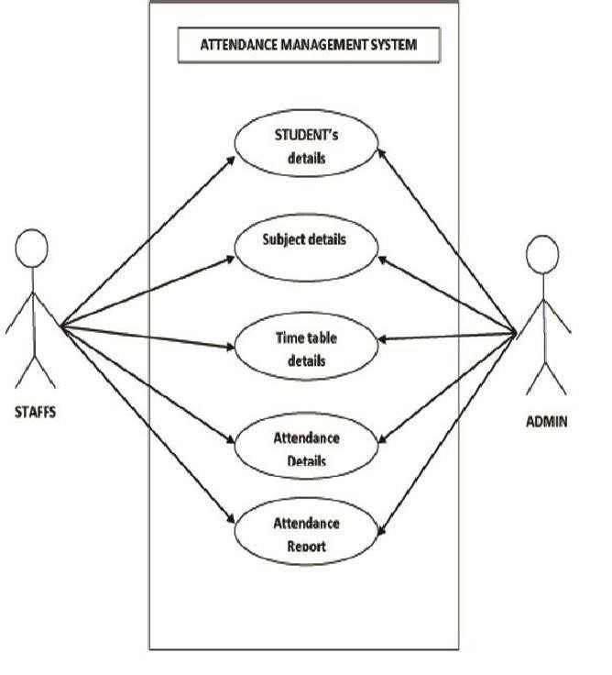

**Figure:5.6 Use Case Diagram**

The use case diagram is usually referred to as behaviour diagram used to describe the actions of all user in a system. All user describe in use case are actors and the functionality as action of system.

The Use case diagram is a collection of diagram and text together that make action on goal of a process.

### SYSTEM FLOW DIAGRAM:

**System Flow Diagram** is basically a graphical and sequential representation of the major steps involved in a systematic process.

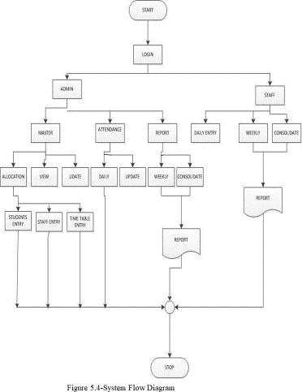

# Dataflow Diagrams:

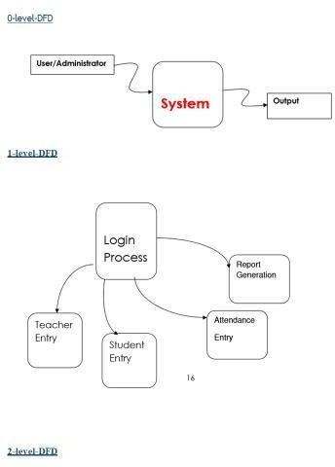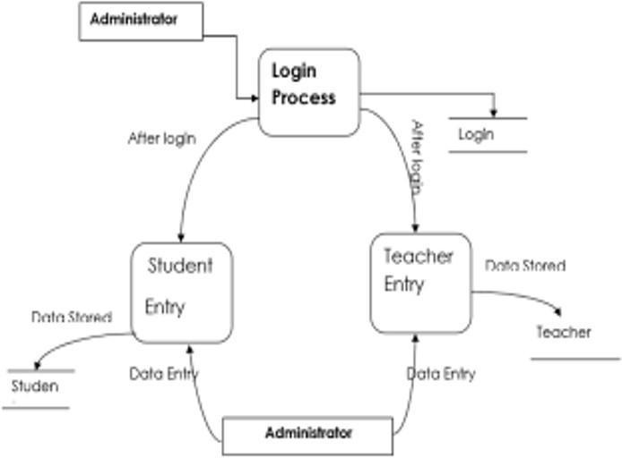

* 1. **ER-Diagram:**

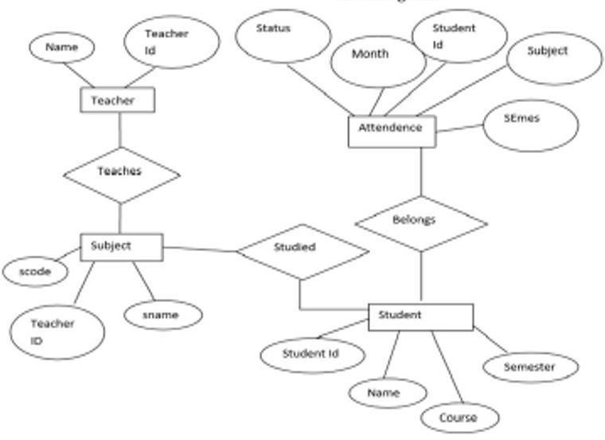

# CHAPTER 5 SNAPSHOTS

### Front End

#### Login Screen:

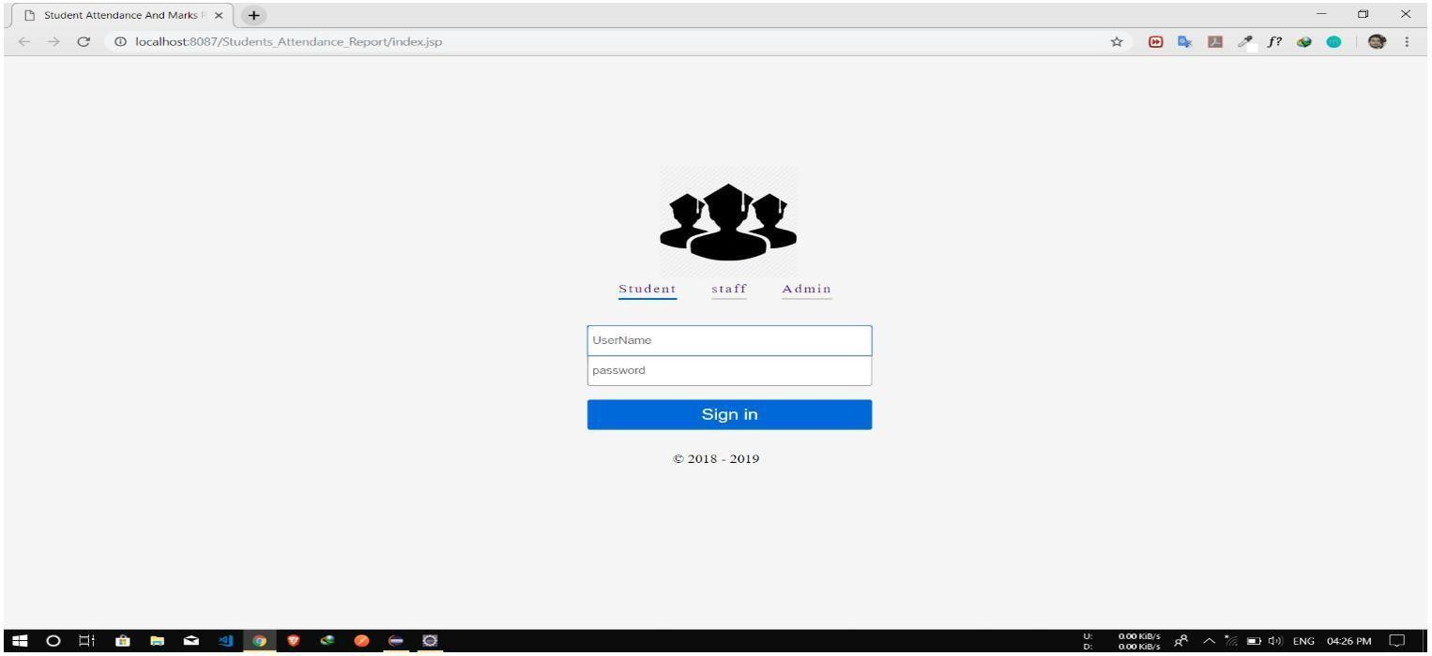

* + 1. **Home Page:**

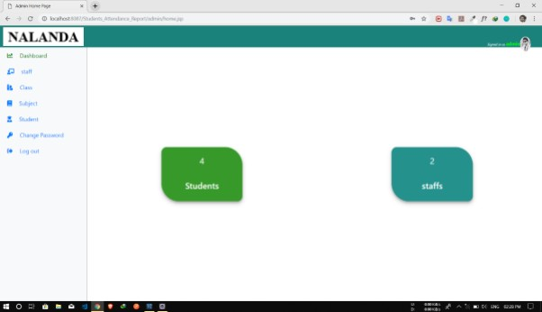

#### Add Student

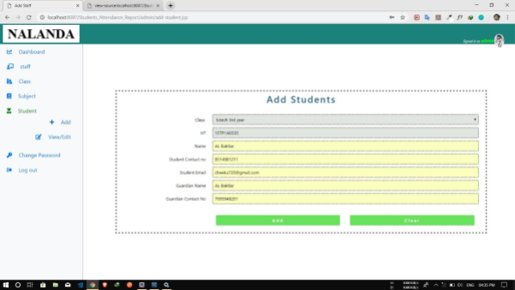

* + 1. **Add Staff**

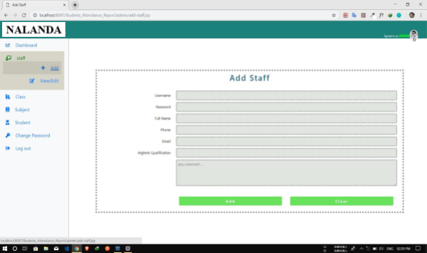

* + 1. **Students List**

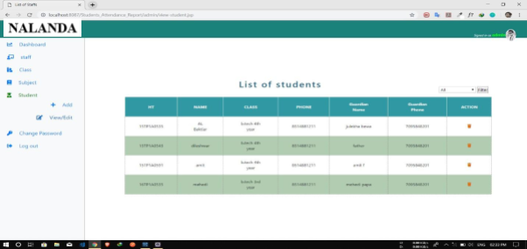

* + 1. **Output View:**

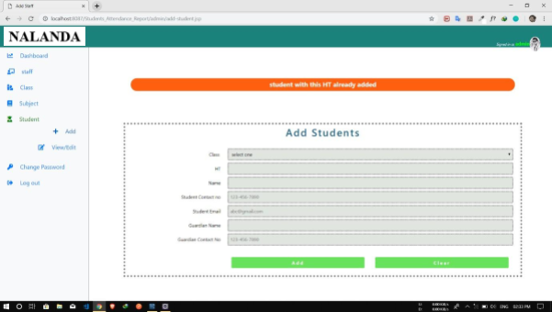

# View for changing Staff & student’s password:

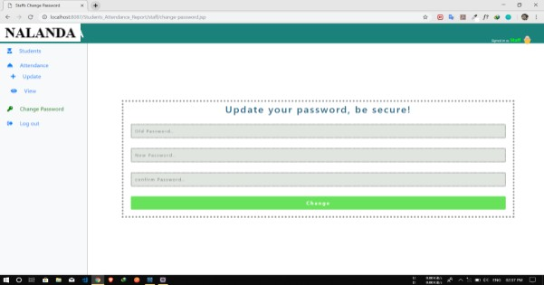

* + 1. **MySQL Work Bench view : ( Showing how students table data looks like)**

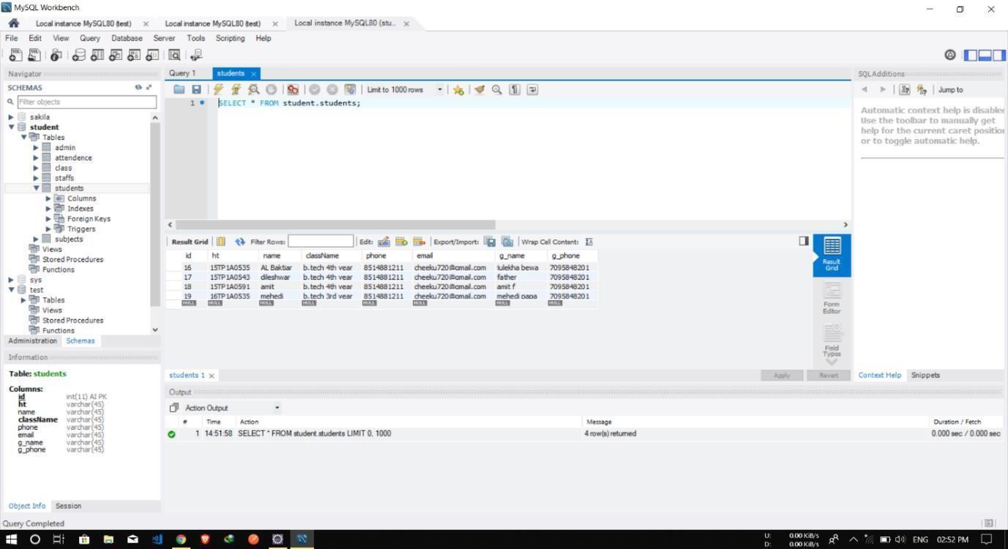

**CHAPTER 6**

# TESTING

### 6.1 Introduction:

Once source code has been generated, software must be tested to uncover (and correct) as many errors as possible before delivery to customer. Our goal is to design a series of test cases that have a high likelihood of finding errors. To uncover the errors software techniques are used. These techniques provide systematic guidance for designing test that,

* + - 1. Exercise the internal logic of software components, and
      2. Exercise the input and output domains of the program to uncover errors In program function, behavior and performance.
      3. **Steps:** Software is tested from two different perspectives:
         1. Internal program logic is exercised using ―White boxǁ test case design Techniques.
         2. Software requirements are exercised using ―block boxǁ test case Design techniques

In both cases, the intent is to find the maximum number of errors with the Minimum amount of effort and time.

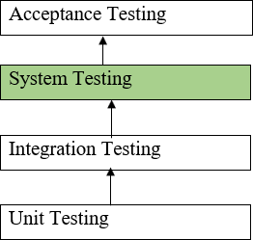

### 2. Testing Methodologies:

A strategy for software testing must accommodate low-level tests that are necessary to verify that a small source code segment has been correctly implemented as well as high-level tests that validate major system functions against customer requirements. A strategy must provide guidance for the practitioner and a set of milestones for the manager. Because the steps of the test strategy occur at a time when deadline pressure begins to rise, progress must be measurable and problems must surface as early as possible. Following testing techniques are well known and the same strategy is adopted during this project testing.

#### Unit testing:

Unit testing focuses verification effort on the smallest unit of software design- the software component or module. The unit test is white-box oriented. The unit testing implemented in every module of student attendance management System. by giving correct manual input to the system, the data are stored in database and retrieved. If you want required module to access input or get the output from the End user. any error will accrue the time will provide handler to show what type of error will accrued.

#### System testing:

System testing is actually a series of different tests whose primary purpose is to fully exercise the computer-based system. Below we have described the two types of testing which have been taken for this project. it is to check all modules worked on input basis. if you want change any values or inputs will change all information. so specified input is must.

#### 6.2.3 Performance Testing

Performance testing is designed to test the run-time performance of software within the context of an integrated system. Performance testing occurs throughout all steps in the testing process. Even at the unit level, the performance of an individual module may be assessed as white-box tests are conducted.

This project reduces attendance table, codes. it will generate report fast.no have extra time or waiting of results. entered correct data will show result few milliseconds. Just used only low memory of our system. Automatically do not getting access at another software. Get user permission and access to other applications.

### Test Cases

* + 1. **Agent and Admin Login Form**

|  |  |  |  |  |  |  |  |
| --- | --- | --- | --- | --- | --- | --- | --- |
| **Sno** | **Test case id** | **Test case name** | **Test case desc** | **Step** | **Expected result** | **Actual Result** | **Test**  **case status pass/fail** |
| 1 | Login | Validate | To verify | Enter the | Login | Login | Pass |
|  | admin | login | that login | login name | successful or | successfu |  |
|  |  |  | name on | and | an error | l |  |
|  |  |  | login page | password | message “In |  |  |
|  |  |  |  | and click | valid login or |  |  |
|  |  |  |  | submit | password” |  |  |
|  |  |  |  | button | must be |  |  |
|  |  |  |  |  | displayed |  |  |
| 2 | Login Staff | Validate | To verify | Enter the | Login | Login | Pass |
|  |  | login | that | login | successful | successfu |  |
|  |  |  | login | name and | or an error | l |  |
|  |  |  | name on | password | message |  |  |
|  |  |  | login | and click | “In valid |  |  |
|  |  |  | page | submit | login or |  |  |
|  |  |  |  | button | password” |  |  |
|  |  |  |  |  | must be |  |  |
|  |  |  |  |  | displayed |  |  |
| 3. | Password | Validate | To verify | Enter | An error | An error | fail |
|  |  | passwor | that | password | message | message |  |
|  |  | d | password on | and login | “password | “password |  |
|  |  |  | login page | name click | invalid” must | invalid” must |  |
|  |  |  |  | submit | be displayed | be displayed |  |
|  |  |  |  | button |  |  |  |

* + 1. **Master Form**

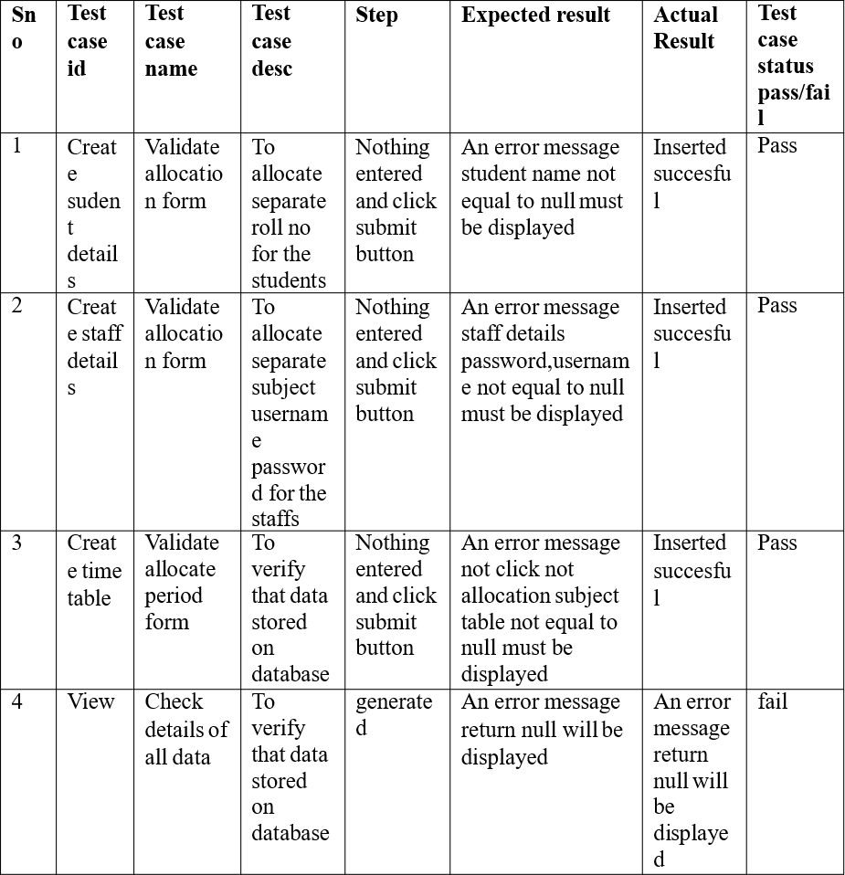

# CHAPTER 7

## CONCLUSION AND FUTURE ENHANCEMENTS

### Conclusion

To conclude, Project Data Grid works like a component which can access all the databases and picks up different functions. It overcomes the many limitations incorporated in the attendance.

* Easy implementation Environment
* Generate report Flexibly

### Future Enhancements

The project has a very vast scope in future. The project can be implemented on intranet in future. Project can be updated in near future as and when requirement for the same arises, as it is very flexible in terms of expansion. With the proposed software of database Space Manager ready and fully functional the client is now able to manage and hence run the entire work in a much better, accurate and error free manner. The following are the future scope for the project. Discontinue of particular student eliminate potential attendance.

* + - Bar code Reader based attendance system.
    - Individual Attendance system with photo using Student login.

# CHAPTER 8

## REFERENCES

* + - 1. Mc GrawHill’s , Java : The complete reference 7thEdition, Herbert Schildit
      2. Sachin Malhotra, Saurabh Choudhary, Programming in Java(2e)
      3. [http://www.stackoverflow.com](http://www.stackoverflow.com/)
      4. [https://www.](http://www.eclipse.org/)eclipse.[org](http://www.eclipse.org/)